**How to use sp_change_users_login to fix SQL Server orphaned users**

Firstly, there may be a number of orphaned users, so the best thing to do is run this inside each database you are checking:

|  |  |
| --- | --- |
| 1 | USE DatabaseName |
| 2 | EXEC sp_change_users_login 'Report'; | |

You will see output like the screenshot attached if there are any orphaned users. In this example, user “db_login1″ is showing up as an orphaned user.

[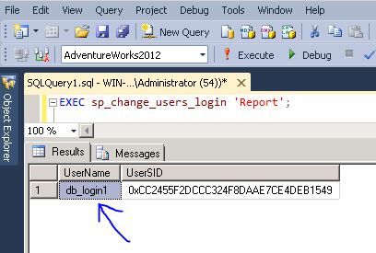](http://dbadiaries.com/wp-content/uploads/2012/09/sp_change_users_login-report.jpg)

If you already have a login which you want to map your database user to, you could run the following (note that the first instance of ‘db_login1′ is the user in the database, the second instance is the login to be mapped to) :

|  |  |
| --- | --- |
| 1 | EXEC sp_change_users_login 'update_one', 'db_login1', 'db_login1'; |

If you don’t already have a login to map to, you can have sp_change_users_login create one for you and with a password. The following code does this and creates a login with the same name and a password of ‘aaZZww77′ as an example.

|  |  |
| --- | --- |
| 1 | EXEC sp_change_users_login 'Auto_Fix', 'db_login1', NULL, 'aaZZww77'; |

[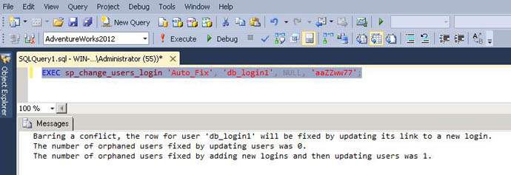](http://dbadiaries.com/wp-content/uploads/2012/09/sp_change_users_login-auto_fix.jpg)

- See more at: http://dbadiaries.com/using-sp_change_users_login-to-fix-sql-server-orphaned-users#sthash.ddn7z2AE.dpuf